Cody Costa

EE263

8/4/2025 resubmission

Homework 1

**PYTHON / MATLAB IMAGE RESULTS:**

Please see attached code files to assignment submission for step-by-step procedure

PROBLEM 1)

Input image: Output Image:

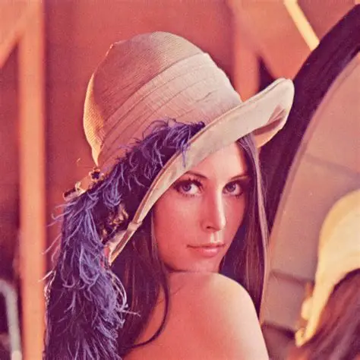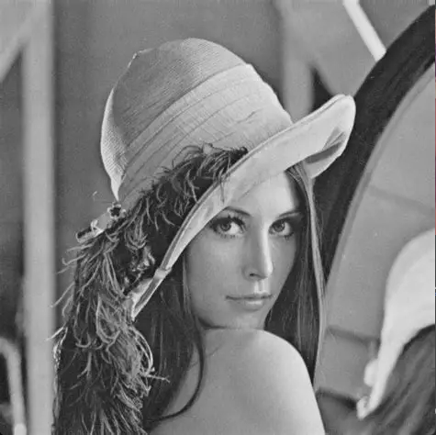

PROBLEM 2)

Input Image:



Output Images:

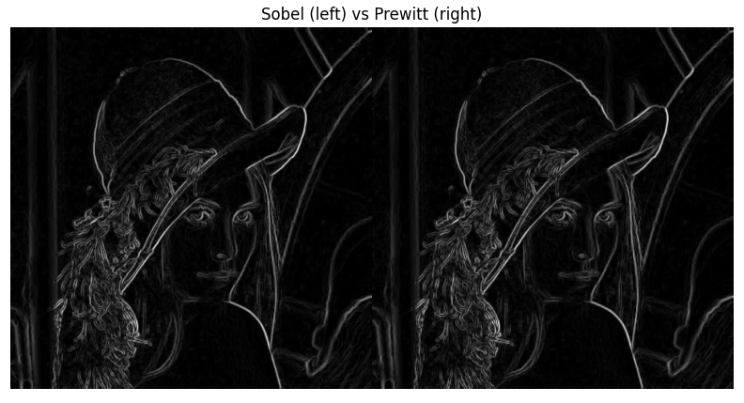

PROBLEM 3)

Input Image:

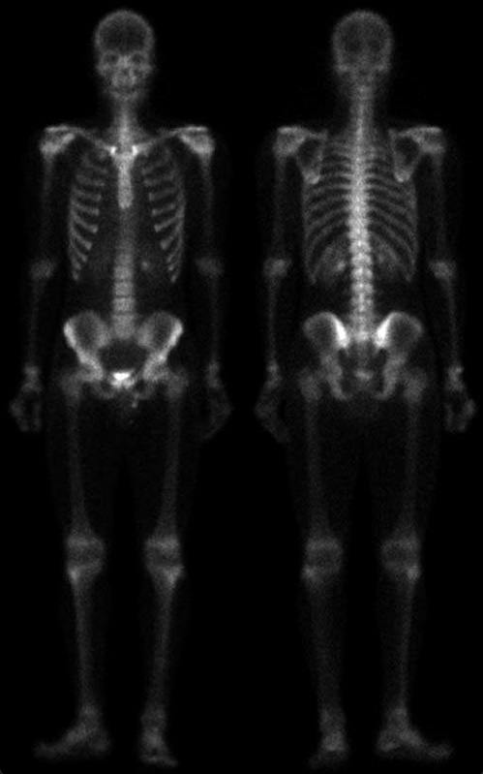

Intermediate images before final enhancement:

Laplacian (left), sharpened (right)

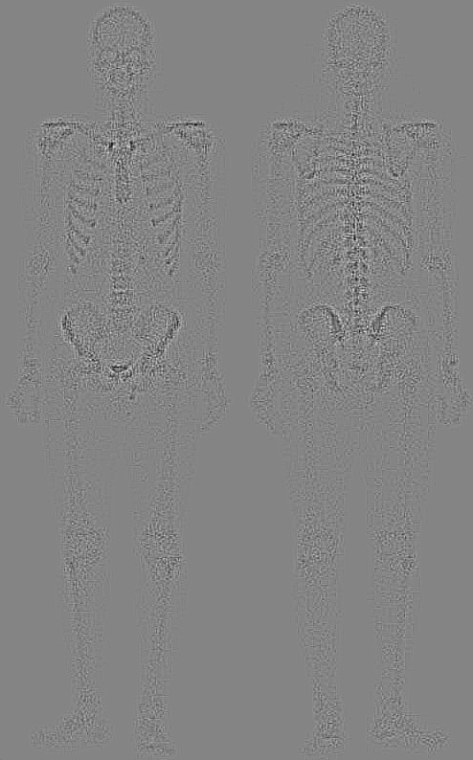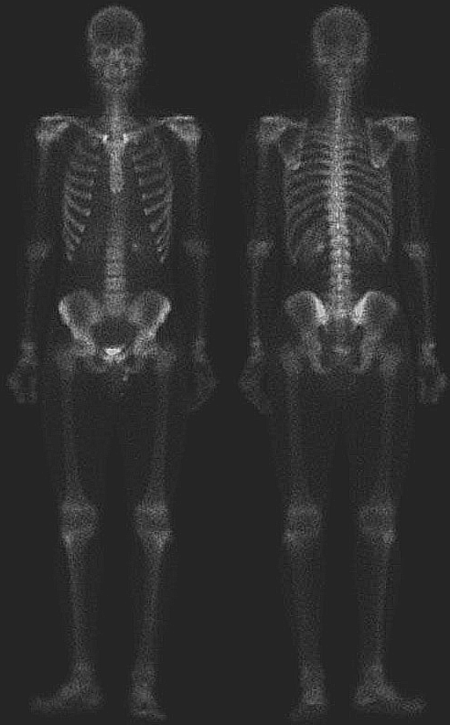

Raw Sobel (left), Smoothed Sobel (right)

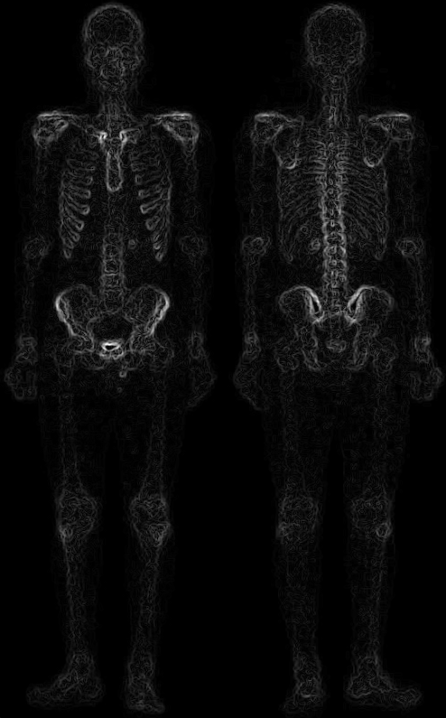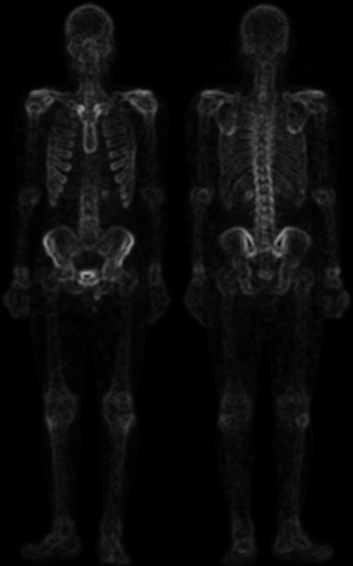

Mask (left), Sharpened Mask (right)

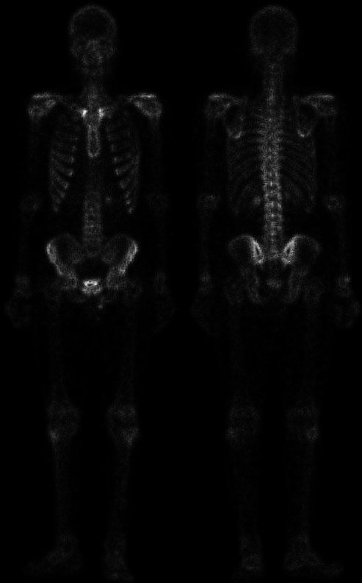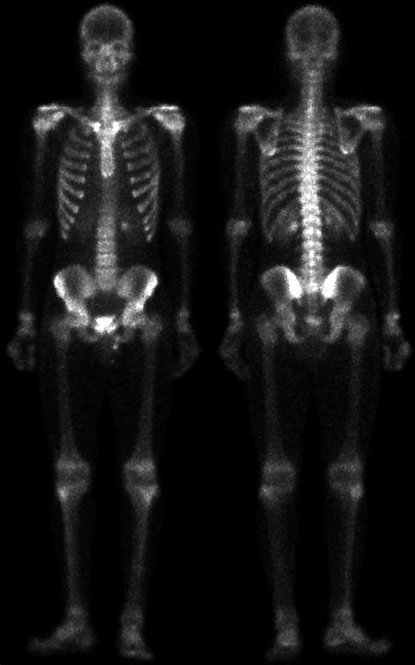

Output Image:

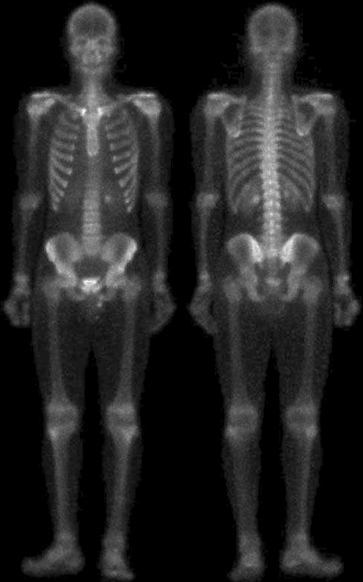

PROBLEM 4)

Input Image:

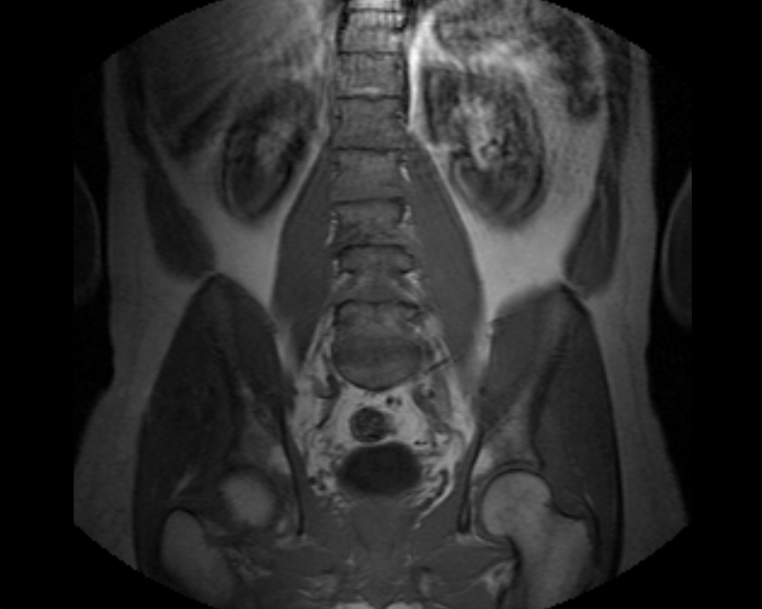

Intermediate images before final enhancement:

Laplacian (left), sharpened (right)

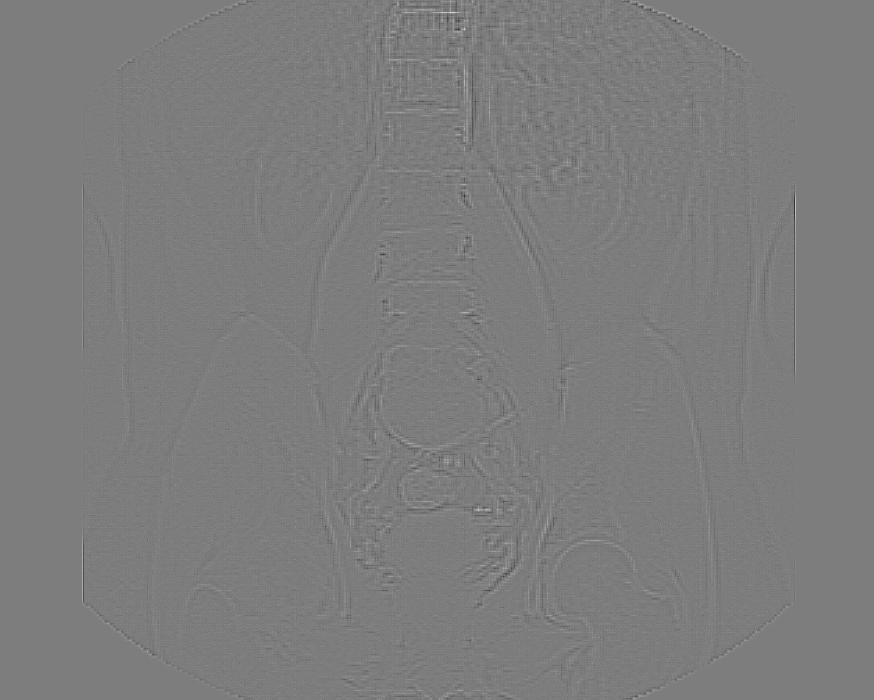 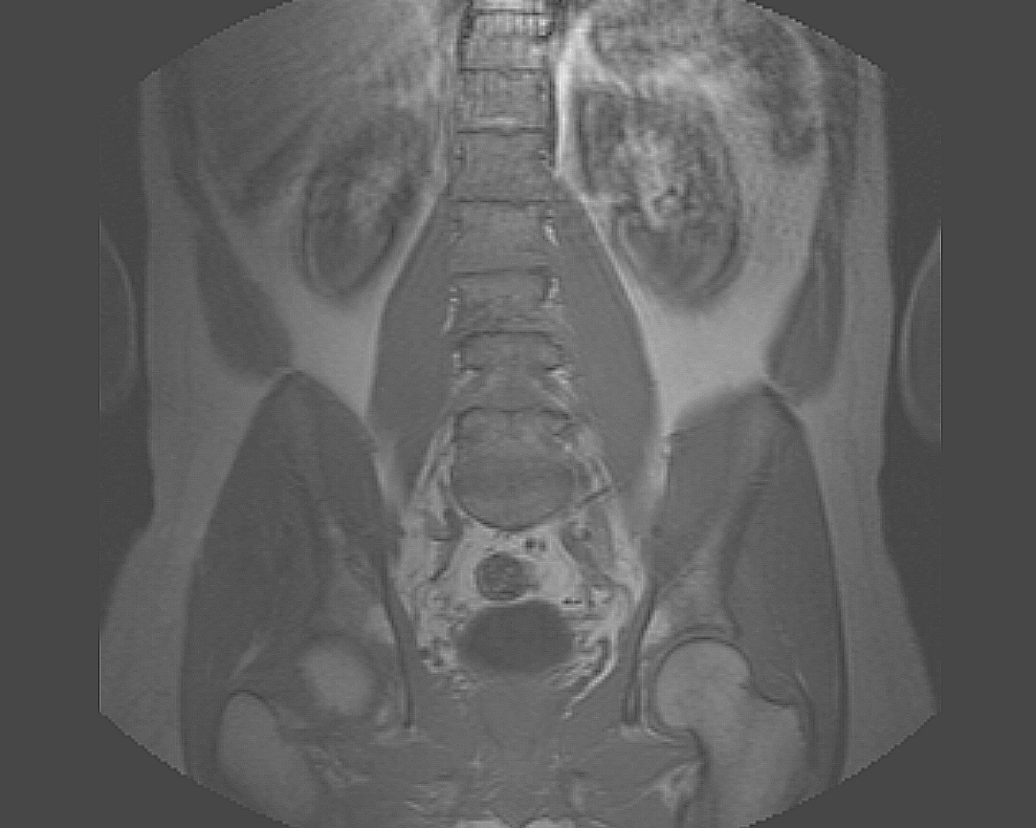

Raw Sobel (left), Smoothed Sobel (right)

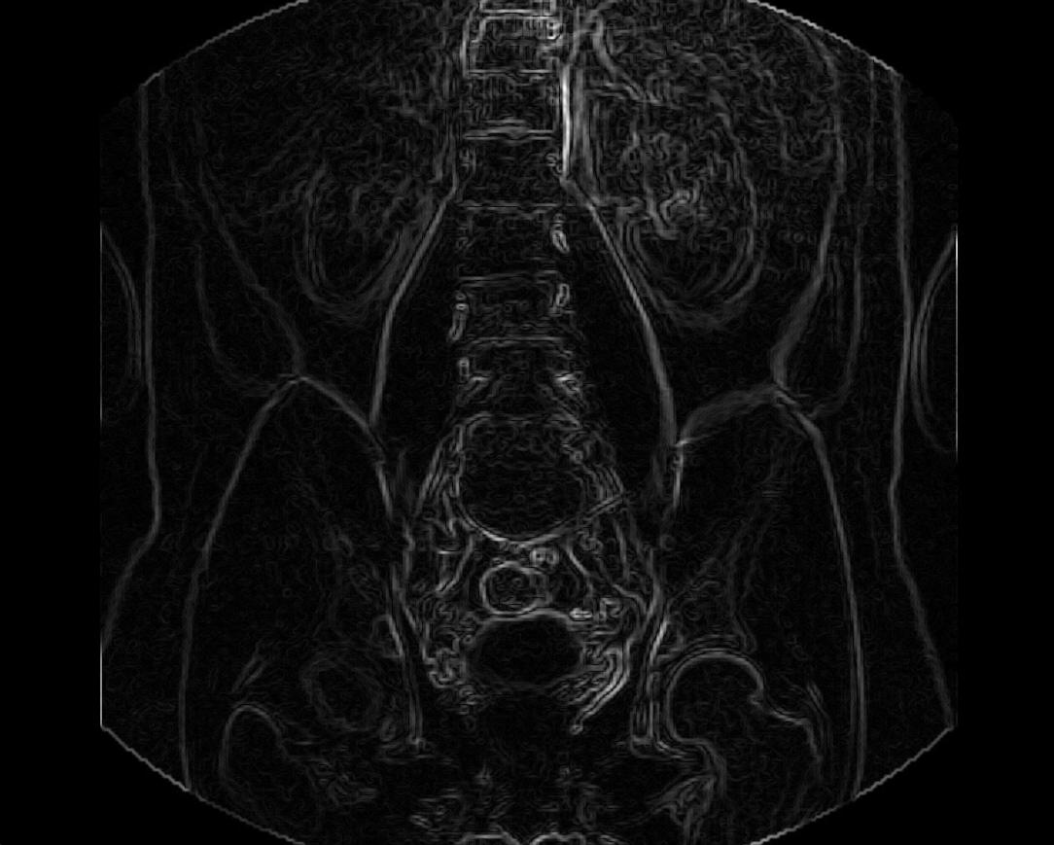 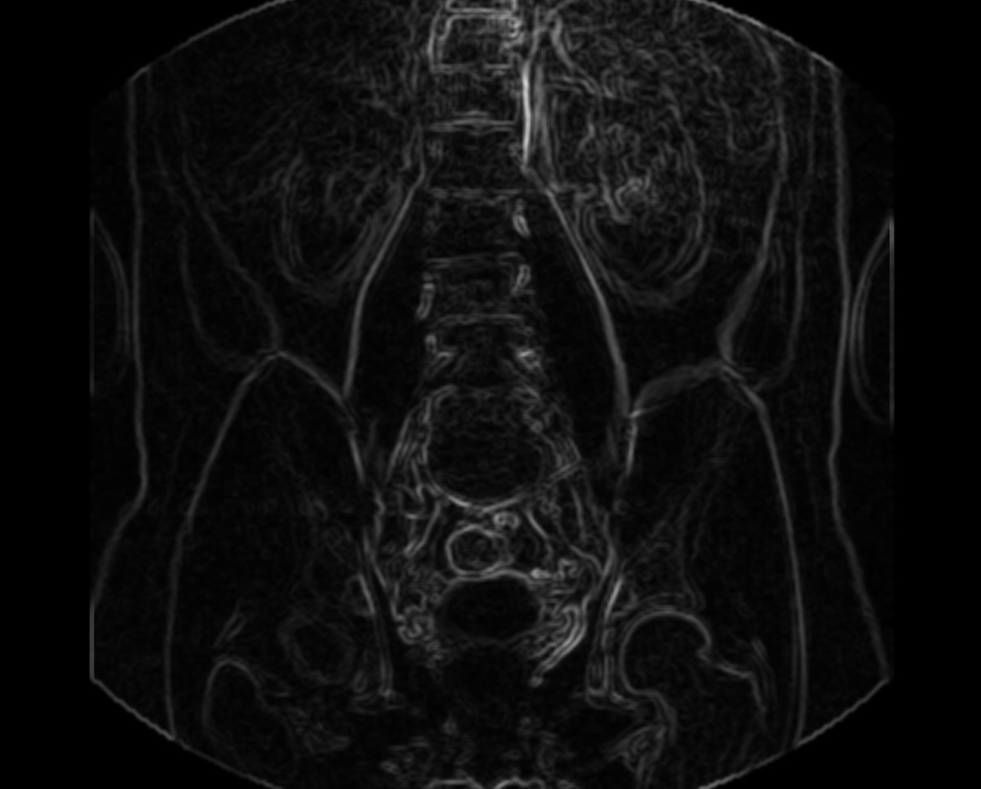

Mask (left), Sharpened Mask (right)

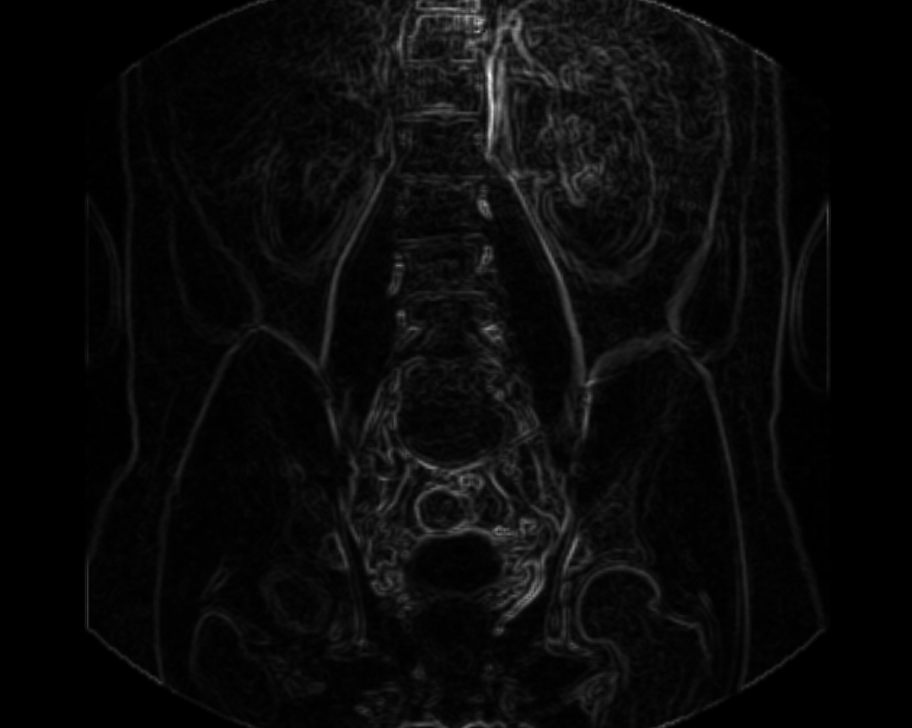 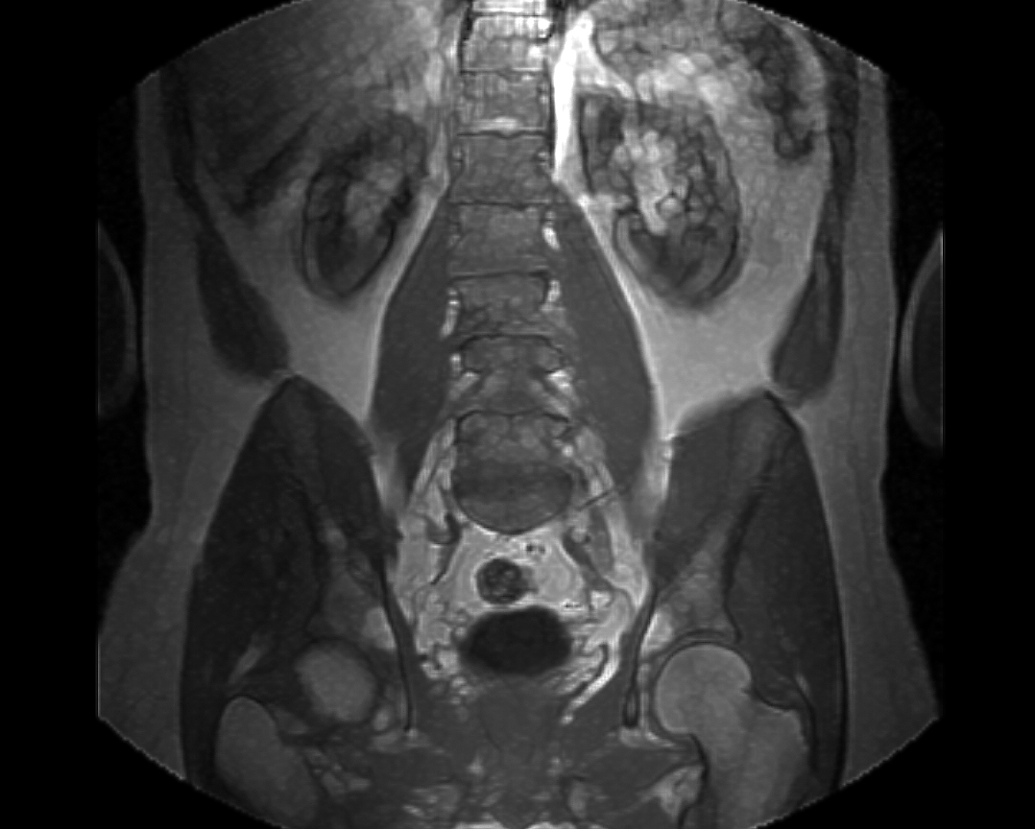

Ouput Image:

